1.数组
package bao;

import java.util.Arrays;

public class SourceTest {

public static void main(String[] args) {
int a;
int[] source = new int[] {1,2,3,4,5};
int[] target = new int[5];
for(int i:source) {
System.out.print(i);
}System.out.println("");
for(a = 0;a < source.length;a++) {
target[a] = source[a];
}
for(int i:target) {
System.out.print(i);
}System.out.println("");
target = new int[5];
for(int i:target) {
System.out.print(i);
}System.out.println("");
System.arraycopy(source, 0, target, 0, 5);
for(int i:target) {
System.out.print(i);
}System.out.println("");
target = new int[5];
for(int i:target) {
System.out.print(i);
}System.out.println("");
target = Arrays.copyOf(source, 5);
for(int i:target) {
System.out.print(i);
}System.out.println("");
}
}

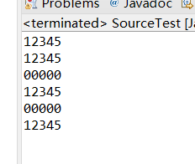

2.学习对象数组的应用
package bao;

public class Student {
private String name;
private int id;
private int grade;

Student(String name,int id,int grade){
this.name = name;
this.id = id;
this.grade = grade;

}

public String getName() {
return name;
}

public void setName(String name) {
this.name = name;
}

public int getId() {
return id;
}

public void setId(int id) {
this.id = id;
}

public int getGrade() {
return grade;
}

public void setGrade(int grade) {
this.grade = grade;
}
}

package bao;

public class StudentTest {
public static void main(String[] args) {
Student[] zu = {new Student("XiaoMing",1,1)
,new Student("XiaoMing",2,2)
,new Student("XiaoMing",3,3)
,new Student("XiaoMing",4,3)
,new Student("XiaoMing",5,4)};
for(Student one:zu) {
if(one.getGrade() == 3) {
System.out.println("姓名:"+one.getName()+",学号:"+one.getId());
}
}
}
}

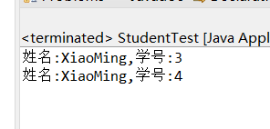

- 成绩
package bao;

public class ResultTest {
public static void main(String[] args) {
int i = 0,j = 0,sum = 0,max = 0,hang = 0,hang2 = 0;
int a1 = 0,a2 = 0,a3 = 0,a4 = 0;
int b1 = 0,b2 = 0,b3 = 0,b4 = 0;
int[][] chengji = {
{80,75,78,93},
{67,87,98,65},
{86,72,60,76},
{76,80,76,63},
{82,70,90,67}};
for(i=0;i<5;i++) {
if(chengji[i][0] > a1) {a1 = chengji[i][0];b1 = i+1;}
}
for(i=0;i<5;i++) {
if(chengji[i][1] > a2) {a2 = chengji[i][1];b2 = i+1;}
}
for(i=0;i<5;i++) {
if(chengji[i][2] > a3) {a3 = chengji[i][2];b3 = i+1;}
}
for(i=0;i<5;i++) {
if(chengji[i][3] > a4) {a4 = chengji[i][3];b4 = i+1;}
}
System.out.print("每科最高分和所在行分别在：["+a1+","+b1+"],["+a2+","+b2+"],["+a3+","+b3+"],["+a4+","+b4+"]");
for(int[] one:chengji) {
for(int hia:one) {
sum += hia;
}
if(sum > max) {max = sum; hang2 = hang;}
sum = 0;hang++;
}
System.out.print("最高分在第"+(hang2+1)+"行,总成绩是"+max);

}
}
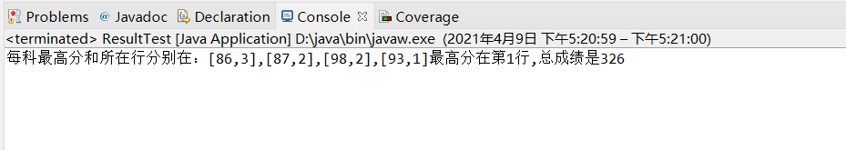

- 漫步
package bao;

public class RandomWalkTest {

public static void main(String[] args) {
int i1 = 0,j1 = 0,a1 = 0,b1 = 0,c1 = 0,d1 = 0;
char[][] ditu = new char[10][10];
char[] zimu = {'A','B','C','D','E','F','G','H','I','J','K','L','M','N','O','P','Q','R','S','T','U','V','W','X','Y','Z'};
for(i1=0;i1<10;i1++){
for(j1=0;j1<10;j1++){
ditu[i1][j1] = '.';
}
}
a1 = (int)(Math.random()*10);
b1 = (int)(Math.random()*10);
ditu[a1][b1] = zimu[c1++];
while(c1 <= 25){
d1 = (int)(Math.random()*4);
switch (d1){
case 0:
a1--;
if(a1>=0&&a1<=9&&ditu[a1][b1] == '.') {ditu[a1][b1] = zimu[c1++];}
else a1++;
break;
case 1:
a1++;
if(a1>=0&&a1<=9&&ditu[a1][b1] == '.') {ditu[a1][b1] = zimu[c1++];}
else a1--;
break;
case 2:
b1--;
if(b1>=0&&b1<=9&&ditu[a1][b1] == '.') {ditu[a1][b1] = zimu[c1++];}
else b1++;
break;
case 3:
b1++;
if(b1>=0&&b1<=9&&ditu[a1][b1] == '.') {ditu[a1][b1] = zimu[c1++];}
else b1--;
break;
}
if((a1==9||ditu[a1+1][b1] != '.')&&(a1==0||ditu[a1-1][b1] != '.')&&(b1==9||ditu[a1][b1+1] != '.')&&(b1==0||ditu[a1][b1-1] != '.'))
{System.out.println("堵死了！");break;}
}
for(char[] i:ditu){
System.out.print("|");
for(char j:i){
System.out.print(j);
}
System.out.println("|");
}

}

}

